Making the Bed
Get Ready  ____ sheets  ____ pillow  ____ blanket | Do  - Put the pillow in the right spot.  - Pull up the sheets.  - Pull up the cover.  - Straighten/smooth everything out | Done  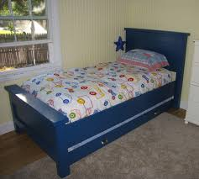
Totally Done

Check the made bed with the photo to
see that it done well.

