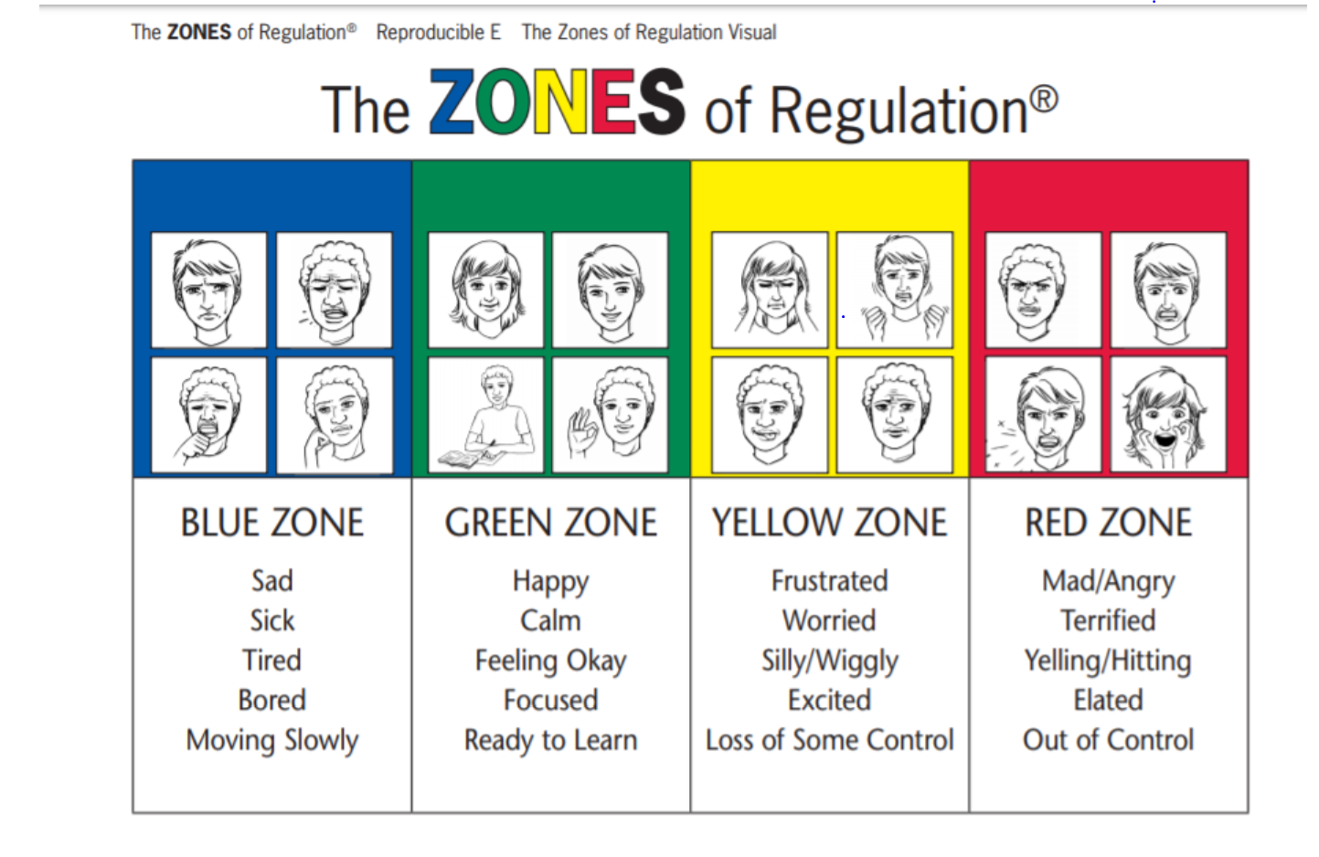

Add a Velcro square on each of the boxes on the previous page. Add the other side of Velcro to an arrow so the arrow can be placed on one of the 4 boxes.