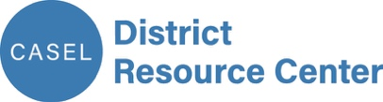

Create a Shared Vision

Districtwide SEL implementation begins with the development of a shared vision that clarifies what you are striving toward and reflects what your district values as critical to students’ education. Ideally, this is an overarching vision that guides and aligns all district work for students. Alternately, you may wish to develop a vision specifically for SEL implementation. Either way, this shared vision should be the basis for your district’s SEL-related goals, plans, allocation of resources, and continuous improvement. Read more about a shared vision at drc.casel.org/build-foundational-support-and-plan/shared-vision-and-plan.

You can use the process outlined here to develop a new vision statement or revisit an existing one. Review your district’s vision and mission statement (sometimes a mission statement is more descriptive and may be more useful), then use this decision tree to determine an appropriate starting point:

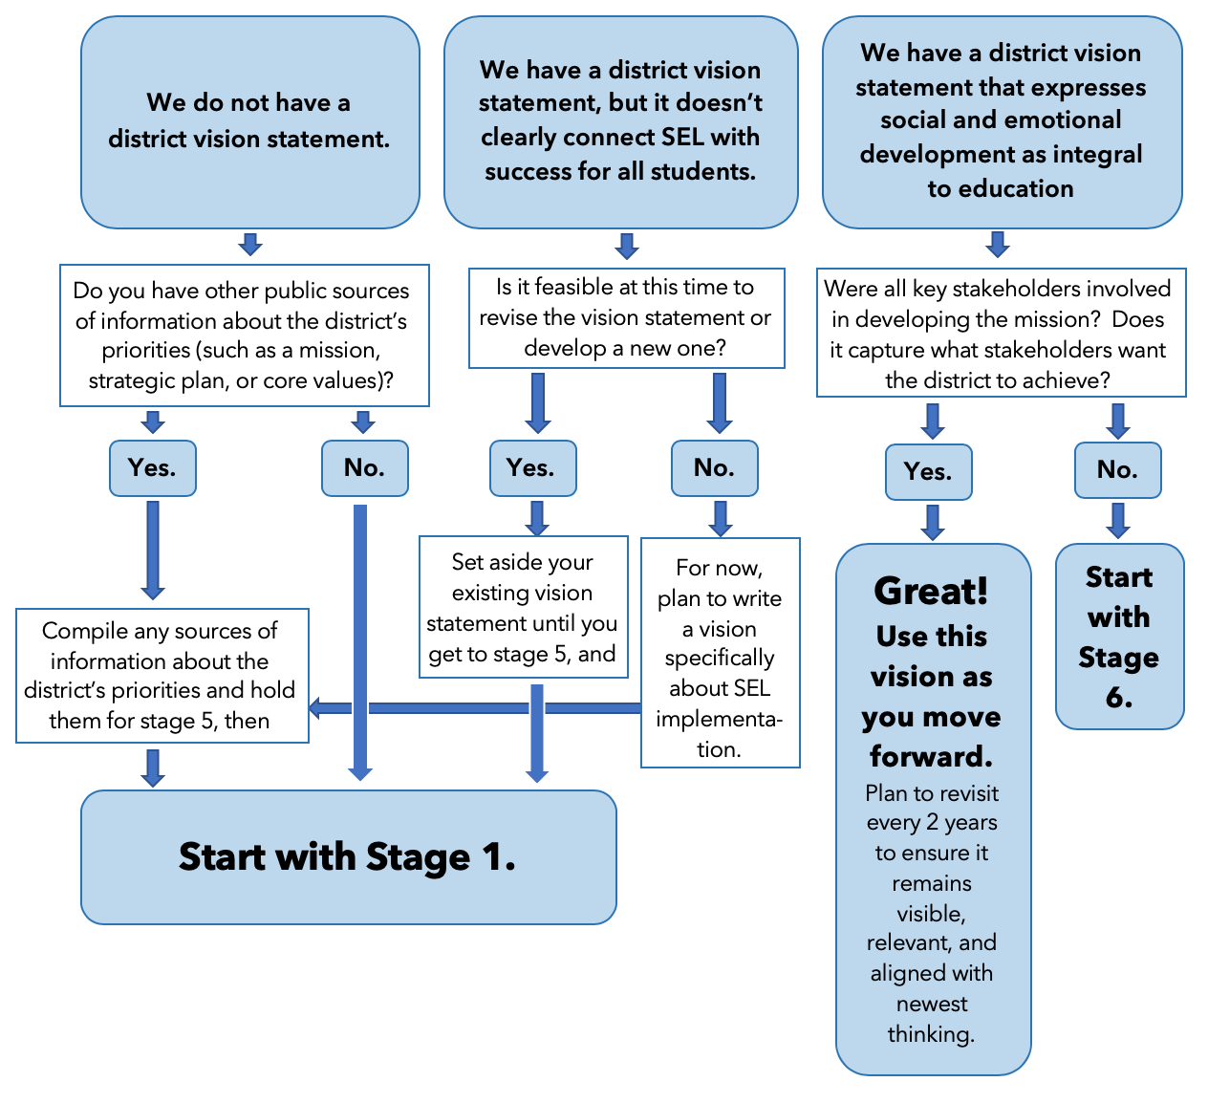
Stage 1: Create a committee to lead the development of the vision statement. Whether you’re developing an overarching districtwide vision or a vision specifically for SEL implementation, you’ll want to bring together a committee to drive the work. Consider staff from all areas: superintendent’s staff, those with strong project management skills, communications staff, and staff who regularly engage with schools, families, and community members. Clearly communicate the group’s responsibilities, how you’ll work together, and the timeline for the work. Some of the roles you may want to consider are:

Role | Names of committee members
Lead/Project Manager (oversees the timeline and plan, and ensures the team stays on track)
Writer(s) (captures notes and summarizes stakeholders’ responses; develops language for vision)
Stakeholder engagement (oversees outreach, planning, and engagement with stakeholders)

Stage 2: Identify stakeholders to shape the vision. Each district is unique and, as a result, may wish to include a particular group of stakeholders in this process. Use the chart below to identify stakeholders who represent diverse perspectives. If you are working with an existing vision statement rather than writing a new one, move ahead to stage 6.

Representation | Names of stakeholders
Senior leaders (i.e., superintendent or designee, board members, cabinet members, department heads)
Representation across key departments:
- SEL - Equity
- Academic content areas - Curriculum and Instruction
- Student services - Health/wellness
- School improvement - Other
School-level representation (principals, teachers, other staff)

Union representation

Families
Community members and leaders of community-based organizations that partner with the district
Students

Stage 3: Learn from stakeholders. You may want to set up small discussion groups, individual interviews, or large group brainstorms with activities like a gallery walk, think-pair-share, etc. To increase participation and align efforts, consider bringing questions before stakeholders through community events or surveys that are already scheduled to take place. Plan questions that ask stakeholders to think about how they want the district to support students. Here are some questions to get you started:

Discussion Questions for Stakeholders
What do we want all students to know and be able to do upon graduation?
What kind of skill-building do you believe is most important in supporting our students to reach their full potential?
What do we want all schools in our district to feel like, sound like, look like? How should students be supported academically, socially, and emotionally?
What do you want our district to look like in 3 years? 5 years? 10 years?
The district has made a commitment to [bring in SEL-related text from public district sources, such as core values, strategic plan, mission, etc.]. What does this mean to you?
As our district focuses on bringing social and emotional learning into the school day, how do you hope it will impact students, the learning environment, and the larger community?

Stage 4: Synthesize stakeholder responses. Compile notes, artifacts, recordings, or survey responses from stage 3, and review as a committee to discuss:
- What are the major themes that emerged from stakeholder responses?
- What words and phrases did we hear that would best paint the picture of an ideal graduate of our school district?
- What words and phrases did we hear that would best paint the picture of a school that will cultivate this kind of graduate?
- How do these themes, words, and phrases connect to academic, social, and emotional learning?
Record themes, words, and phrases on chart paper or on a screen so committee members can confirm that all stakeholders’ views are accurately represented as they are synthesized.

Stage 5: Draft a vision statement. The writer(s) can now take the themes and phrases and craft them into a vision statement. You may want to draw upon words, phrases, or themes from other sources (mission, strategic plan, core values, etc.) to write a vision statement that is consistent with other district plans. Consider drafting a few versions. Here’s a quick checklist to help keep the vision on the right track:
- The views of stakeholders are accurately represented in the statement.
- Stakeholder input was collected and incorporated in an equitable way.
- The statement paints a clear picture of student success.
- The statement captures how the district and schools will support students in developing academically, socially, and emotionally.
- Language is accessible and memorable.

Stage 6: Gather stakeholder feedback on the vision statement. Whether you are working with a draft vision statement from stage 5 or an existing statement, bring in a broad coalition of stakeholders to review, adjust, and approve this key statement, as it will later drive action planning for systemic SEL implementation. Determine if any senior leaders should review the statement prior to seeking feedback districtwide. Then, reconnect with stakeholders (see stage 2) to find out what the vision statement means to them and whether it matches what they believe to be important and compelling. If it isn’t possible to reconvene, request feedback by email or through an online collaboration tool. Share a timeline for finalizing the vision statement and inform participants whether they’ll see another version before it is published.

Questions for feedback on draft
Does this vision statement reflect what you believe is most important in supporting our students to reach their full potential? Please share a bit about your answer.
Does this vision statement capture what you believe the district should be striving for? Please share a bit about your answer.
Which words, phrases, or sentences are most important?
Which words, phrases, or sentences spark questions or concerns?
What, if anything, would you add to this vision statement?

Stage 7: Finalize the vision statement. If you began with stage 1, bring the committee back together to review feedback and incorporate outstanding points. Finalize your vision statement or repeat this process as needed. If you are recommending revisions to an existing vision statement, provide district decision-makers (e.g., communications team, senior leaders) with a summary of stakeholder feedback and one or more revised versions for approval.

With your final shared vision, you’ve begun to answer the question “where do we want to go?” in relation to systemic SEL implementation, and you are ready to move on to the next stage in SEL action planning: Define long-term goals for SEL implementation.

