TOOL: Using an SEL lens to review the vision and/or mission of a school district or organization

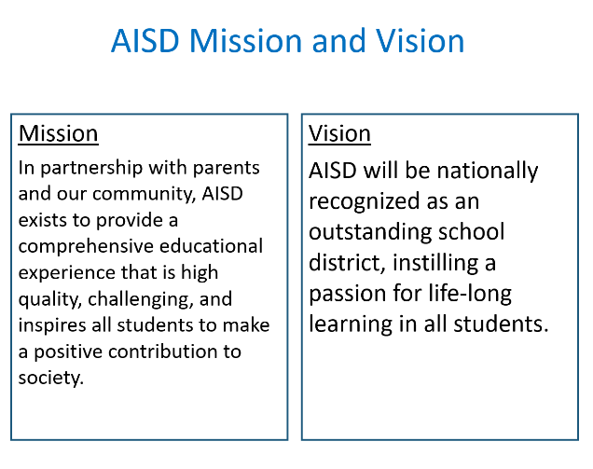
PREPARING THE ACTIVITY:

- Prepare a slide with the District, School, or Organization Vision and Mission. (Example from Austin Independent School District to the right)

FACILITATION STEPS:

NOTE: This is a fairly quick way for a board or leaders to take a look at their vision and/or mission to see if they already include any aspect of SEL. It is also a good final activity for leaders who have just participated in an SEL introductory or advanced workshop. Before doing this activity, the group should have, at minimum, an introduction to SEL, the five competencies, and the research. Preferably they have taken part in experiential and teambuilding activities, or they were already a tightknit team. The intention is to have the group realize that SEL is required if we are to meet our vision and mission.

- A short thank you for devoting time, for coming to the workshop, for being great participants, etc.

- “This should look familiar. These are the mission and vision of the District. I am going to begin reading through the Mission and I want you to raise your hand when I read a word or phrase which either requires SEL or is enhanced by SEL.”

- Using the AISD example:
  - “In partnership” A hand goes up.
    - “Tell me about that.” or “What about SEL would enable or strengthen partnership?”
    - Participant(s) respond.
  - “In partnership with our community” A hand goes up.
    - “What about community requires or is enhanced by SEL?”
    - Participant(s) respond.
  - “In partnership with our community, AISD exists to provide a comprehensive educational experience” A hand goes up.
    - Facilitator calls on someone with their hand up. (No need to repeat the question at this point.)
    - Participant(s) describe how SEL is part of the comprehensive educational experience.

- Facilitator continues reading the mission, starting over at the beginning each time. This is a great opportunity for the group to remind themselves as to their mission, as well as a clear way of demonstrating the necessity of SEL to meet that mission.

- Repeat for Vision.

- After completing the reads and responses, facilitate the group, so that they are saying, “we need SEL” and “I can’t believe we haven’t been doing this systematically”. If the timing is right, have the Board president or leader of the group use this moment to get agreement/commitment to move SEL forward. Outline the agreements made during the evening by listing them on chart paper.

- Move into evaluation/feedback session.

FACILITATION NOTES:

- If the organization has only a vision or only a mission, it is fine to just do one. If there are both a vision and a mission, determine which to do first.
- Keep it moving. If this is the final activity after an introduction to SEL and its evidence base (recommended) participants’ attention may be waning. Try to keep to one quick comment per raised hand.

